



The Tenth Session of the
SOUTH-EAST EUROPEAN CLIMATE OUTLOOK FORUM (SEECOF-10)
20-21 November, 2013

SEASONAL OUTLOOK FOR THE WINTER SEASON 2013/2014 FOR THE SOUTH EASTERN EUROPE AND CAUCASUS REGION (SEE&C)

Climate experts from WMO RA VI RCC Network Node on long-range forecasting (Meteo France, France and Roshydromet, Russia) and WMO RA VI RCC Network Node on climate monitoring (Deutscher Wetterdienst, Germany), UK Met-Office, Global Producing Centre ECMWF, International Research Institute for Climate and Society (IRI, USA), National Centers for Environmental Prediction (NCEP, USA), South East European Virtual Climate Change Centre (SEEVCCC, Serbia) and National Hydrometeorological Services of the SEECOF region provided their valuable contribution to the successful implementation of SEECOF-10 by developing the relevant documents and providing their scientific guidance and recommendations.
SEECOF-10 was comprised of the following Steps:
- Step 1: assessment of the current state of the climate, including large-scale climate patterns worldwide, and assessments of its likely evolution in the course of the next months;
- Step 2: building the consensus forecast for the 2013/2014 winter season in consistency with the MedCOF-1 consensus statement.
All relevant documentation is posted and updated in the SEEVCCC web site: http://www.seevccc.rs

SEECOF-10 CLIMATE OUTLOOK
FOR THE 2013/14 WINTER SEASON

Similarly to the MedCOF-1 seasonal outlook, SEECOF-10 prediction is based on the output from dynamical models, including, inter alia, the operational products of the SEEVCCC centre, statistical models and known teleconnections of large-scale climate features.
Sea surface temperatures have been near to normal for the autumn season in the Equatorial Pacific. These conditions are very likely to persist for the coming winter season. No clear signal appears for the winter season neither from the tropics nor from other sources of predictability, e.g., the North Atlantic Oscillation index, etc. The regional response to large scale drivers is modulated by the conditions of the above normal SSTs of the Mediterranean, which could lead to locally intense precipitation episodes under a favourable atmospheric circulation.
The maps show the probabilistic consensus forecast for the tercile categories of anomalies for seasonal mean temperature and precipitation, relative to the period 1981-2010. Due to the climate warming trend anomalies are affected by the selected reference period.

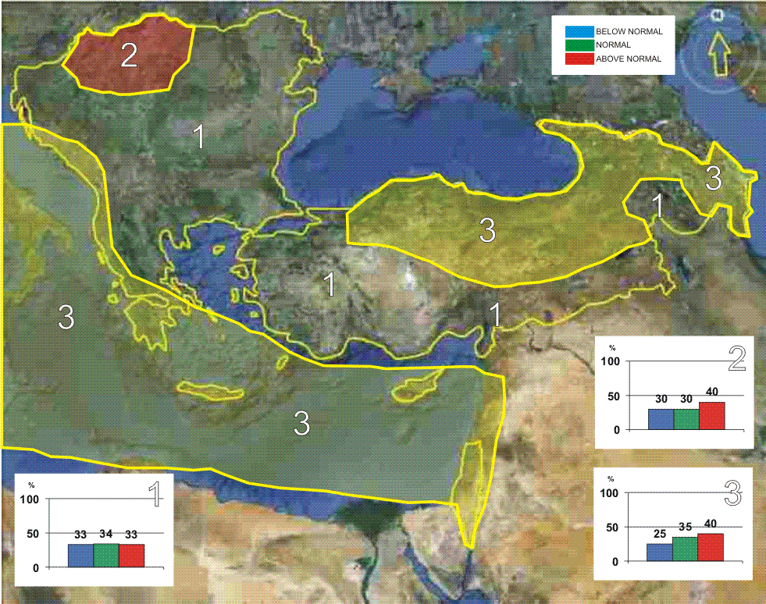

Figure 1. Graphical presentation of the 2013/14 winter temperature outlook

Although for most of the domain the uncertainty for the temperature prediction is high, there is a weak tendency for the upper tercile in Hungary, some inland and the eastern part of Turkey, Georgia and Azerbaijan, together with the eastern and central Mediterranean, the Ionian Sea, the southern and central parts of the Adriatic Sea with belonging coasts (zones 2 and 3 in Figure 1). In the rest of the SEECOF region (zone 1 in Figure 1) climatology is assigned for all three categories.

It must be emphasised that even in the event of seasonal mean temperature near or above the long-term average, cold periods are still possible.
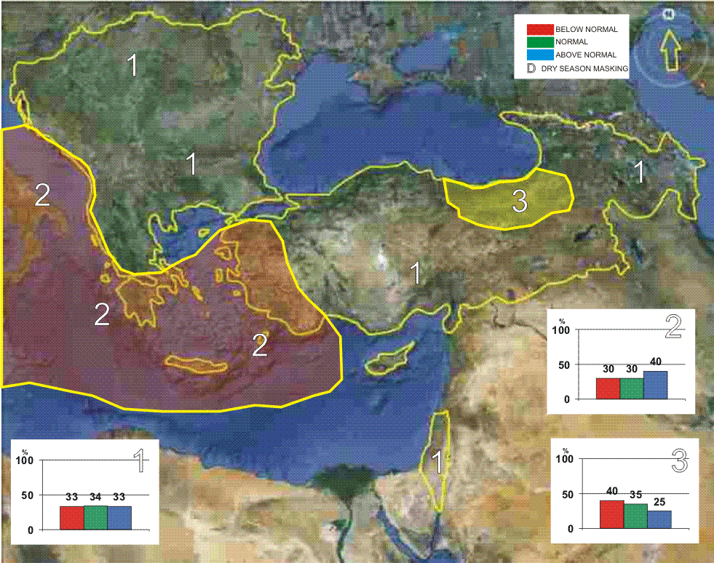

Figure 2. Graphical presentation of the 2013/14 winter precipitation outlook

Precipitation in the largest part of the SEECOF domain shows no preference for any climate defined categories (zone 1 in Figure 2). The central Mediterranean, the southern part of the Aegean Sea, the Ionian Sea and most of the Adriatic Sea with belonging coasts show some tendency for the wet tercile (zone 2 in Figure 2), whereas the Eastern Black Sea region of Turkey slightly points to the dry tercile (zone 3 in Figure 2).
Note that it is necessary to express seasonal forecasts in terms of probability due to inherent uncertainty. Any further advice on the forecast signals, shorter-range updates and warnings will be available throughout the winter from the National Meteorological Services, along with the details on the methodology and skill of long-range predictions.

Note: The graphical representation of climate outlook in this statement is for guidance purposes only, and does not imply any opinion whatsoever concerning the legal status of any country, territory, city or area or of its authorities, or concerning the delimitation of its frontiers or boundaries.

SERBIA CLIMATE OUTLOOK
FOR THE 2013/2014 WINTER SEASON

The winter of 2013/2014 will mark the average climate features across much of Serbia. The coldest period is expected during January, however the entire winter season will characterize the alternation of cold and warm periods.
The mean air temperature during winter 2013/2014 is expected to be within average values ranging from (-1ºС to +5ºС in low-lying areas and from -6ºС to +1ºС in mountain regions).
The precipitation sums during the upcoming winter season will characterize values within the multi-annual average ranging from 90 mm on the north of Pannonian Basin to 140 mm in southwestern Serbia, whereas in hilly-mountain areas, certain places will receive up to 240 mm of precipitation.
The number of frost days with the minimum air temperature below 0ºС during December, January and February will range between 54 and 72 (around 50 in Belgrade) while in the hilly-mountain areas its number will reach 80.
The number of ice days (with the maximum air temperature below 0ºС) will be in a range from: 15 in Belgrade, elsewhere in Serbia between 14 - 30 and around 40 in hilly-mountain areas.

APPENDIX: Contributors to SEECOF-10

- World Meteorological Organization
- Met Office, United Kingdom
- International Research Institute for Climate and Society, United States of America
- European Center for Medium Range Weather Forecast
- Meteo France, Republic of France
- Deutscher Wetterdienst, Federal Republic of Germany
- National Center for Environmental Prediction, United States of America
- South East European Virtual Climate Change Center hosted by Republic Hydrometeorological Service of Serbia, Republic of Serbia
- Institute of Geosciences, Energy, Water and Environment, Albania
- Armenian State Hydrometeorological and Monitoring Service, Armenia
- National Institute of Meteorology and Hydrology, Republic of Bulgaria
- Meteorological and Hydrological Service, Republic of Croatia
- Meteorological Service, Republic of Cyprus
- Hellenic National Meteorological Service, Greece
- The National Environmental Agency of Georgia, Georgia
- Hungarian Meteorological Service, Hungary
- Israel Meteorological Service, State of Israel
- Republic Hydrometeorological Institute, Former Yugoslav Republic of Macedonia
- Hydrometeorological Institute of Montenegro, Montenegro
- National Meteorological Administration, Romania
- Federal Hydrometeorological Service of the Federation of Bosnia and Herzegovina, Federation of Bosnia and Herzegovina, Bosnia and Herzegovina
- Republic Hydrometeorological Service of the Republic of Srpska, Republic of Srpska, Bosnia and Herzegovina
- Republic Hydrometeorological Service of Serbia, Republic of Serbia
- Turkish State Meteorological Service, Republic of Turkey

